**Quant Art – White Paper**

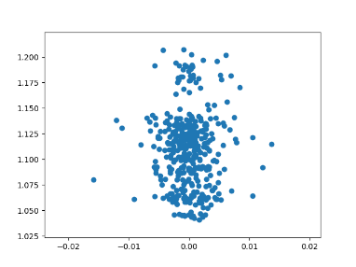The goal of this document is to outline an artistic project where the art will be broadly abstract. Personally, this is a project to explore my own creativity, broaden my skillsets into web design.

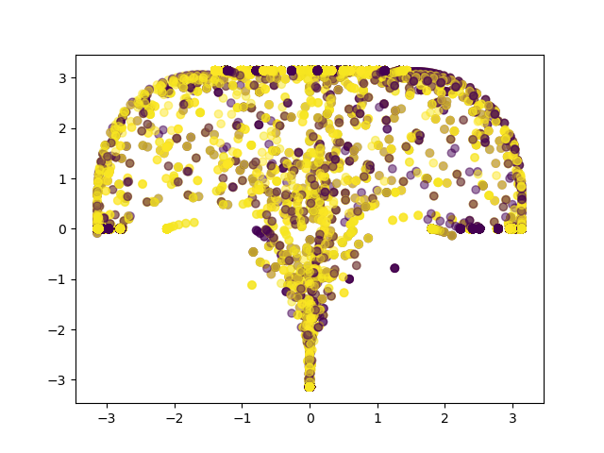A means of exploring and experimenting with the world through art. The randomness naturally found in nature will be used to select image elements such as the sizes, shapes and colors. This will employ parametric curves, clustering, color analysis. This is also for the development of your own data visualization and communication skills. Idea of use the same mathematical models used to analyze the markets in order to create art.

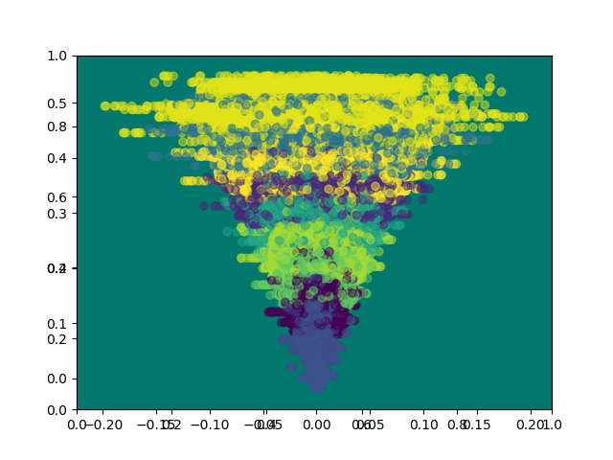Recent trends in big data and machine learning have been in the pursuit of insights. This project will explore these techniques with the goal of creating beauty. Visualizing data in compelling ways. The premise being that the aesthetics are the honey that opens conversations to the data.

As an example, the images to the right explore projecting trading profits versus the entry prices into images. Each data point is put through a different vector field in order to create these images.

**Future Research Directions**

* **Processing Front-End:** Using processing as a front end for visualizing data and exploring the ways in which processing may be a useful tool for data visualization.
* **Evolutionary Pipeline:** Use of evolutionary algorithm to generate pictures based on feedback and input parameters.

Resources:

<https://www.math.uic.edu/math210/labpages/lab7>

<https://mathinsight.org/vector_field_overview>

<https://www.whitman.edu/mathematics/calculus_online/section16.01.html>